“Logging using SLF4J”
Exercise 1: Logging Error Messages and Warning Level , Write a Java application that demonstrates logging error messages and warning levels using SLF4J.
SOLUTION:
1.LoggingExample.java
import org.slf4j.Logger;
import org.slf4j.LoggerFactory;
public class LoggingExample {
private static final Logger logger = LoggerFactory.getLogger(LoggingExample.class);
public static void main(String[] args) {
logger.error("This is an error message");
logger.warn("This is a warning message");
logger.info("This is an info message");
logger.debug("This is a debug message");
}
}
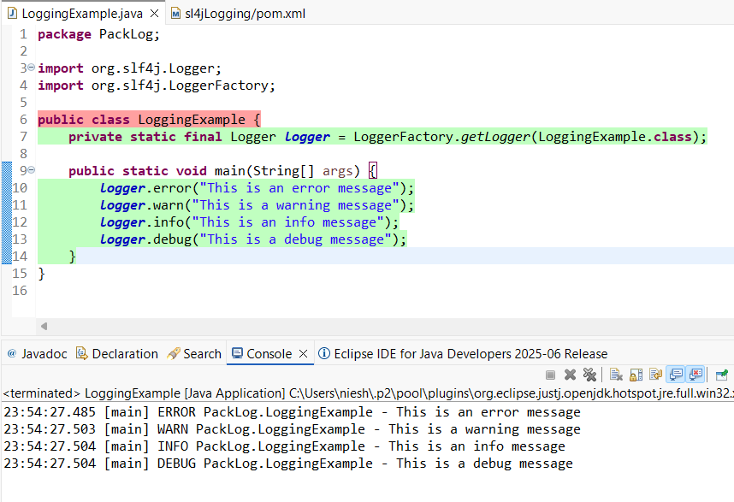
---------------------------------------------------------------------------------------------------------------------------
Exercise 2: Parameterized Logging Task: Write a Java application that demonstrates parameterized logging using SLF4J.
SOLUTION:
1.ParametrizedLoggingExample.java
import org.slf4j.Logger;
import org.slf4j.LoggerFactory;
import java.time.LocalDateTime;
public class ParametrizedLoggingExample {
private static final Logger logger = LoggerFactory.getLogger(ParametrizedLoggingExample.class);
public static void main(String[] args) {
String username = "Gunashree";
String operation = "Login";
LocalDateTime timestamp = LocalDateTime.now();
logger.info("User {} performed {} at {}", username, operation, timestamp);
logger.warn("Low disk space on server {}: {}% used", "Server-1", 92.5);
logger.error("Exception occurred for user {}: {}", username, "NullPointerException");
}
}
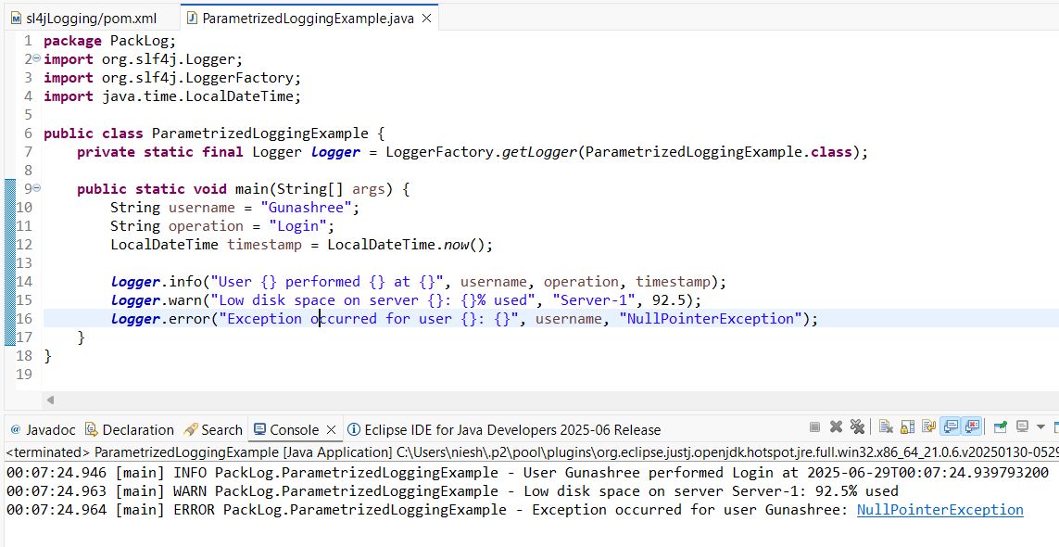
---------------------------------------------------------------------------------------------------------------------------

Exercise 3: Using Different Appenders Task: Write a Java application that demonstrates using different appenders with SLF4J.
SOLUTION:
1.LoggerExample.java
import org.slf4j.Logger;
import org.slf4j.LoggerFactory;
public class LoggerExample {
private static final Logger logger = LoggerFactory.getLogger(LoggerExample.class);
public static void main(String[] args) {
logger.info("Application started");
logger.debug("Debug level message");
logger.warn("Warning level message");
logger.error("Error level message");
System.out.println("Check console and logs/app.log for log outputs.");
}
}



